# **Create new Play Framework project**

1. Go to Play Framework homepage, click Download -> Download Play Java Starter Example.

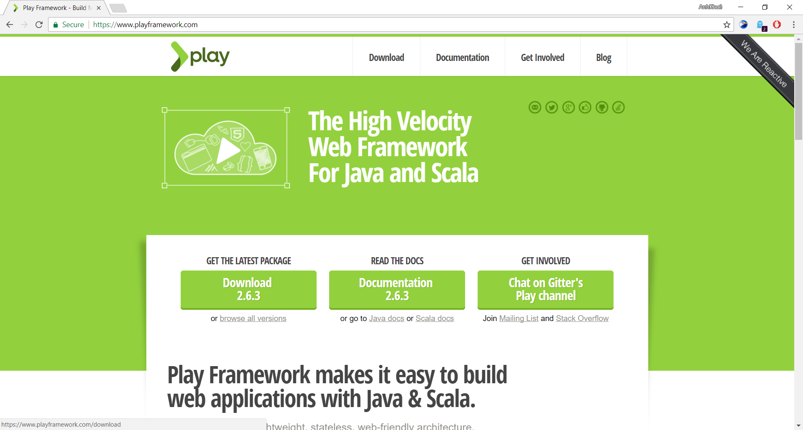

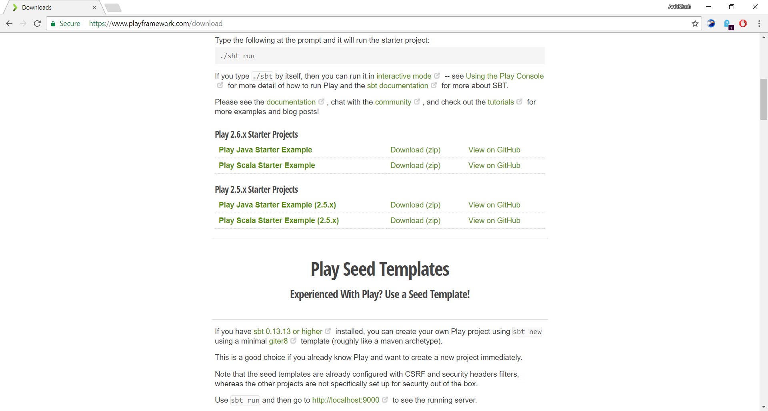

1. 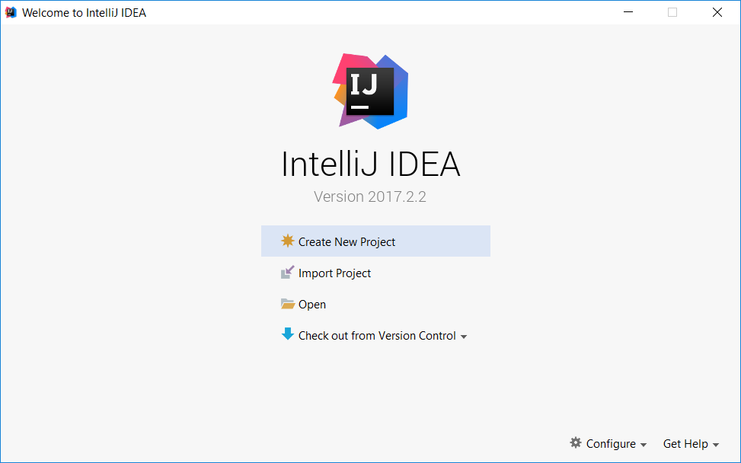Extract the downloaded project and open IntelliJ.
2. 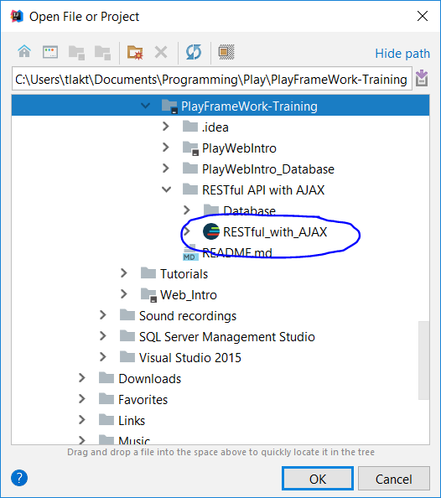Click Open and select to the path where you extracted the project. IntelliJ now easily realized this as a SBT Project -> Click OK.
3. Check if the SBT Sources checkbox is selected before continue.

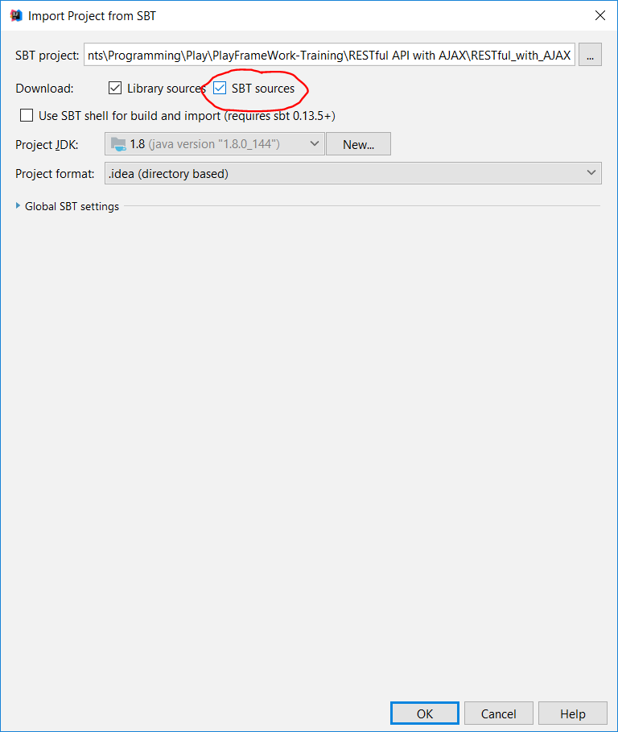

1. Wait about 2 minutes for IntelliJ finishing downloading/resolving necessary dependencies and libraries. Then go to Settings -> Languages & Frameworks -> Play 2 and select “Use Play 2 compiler for this project.”

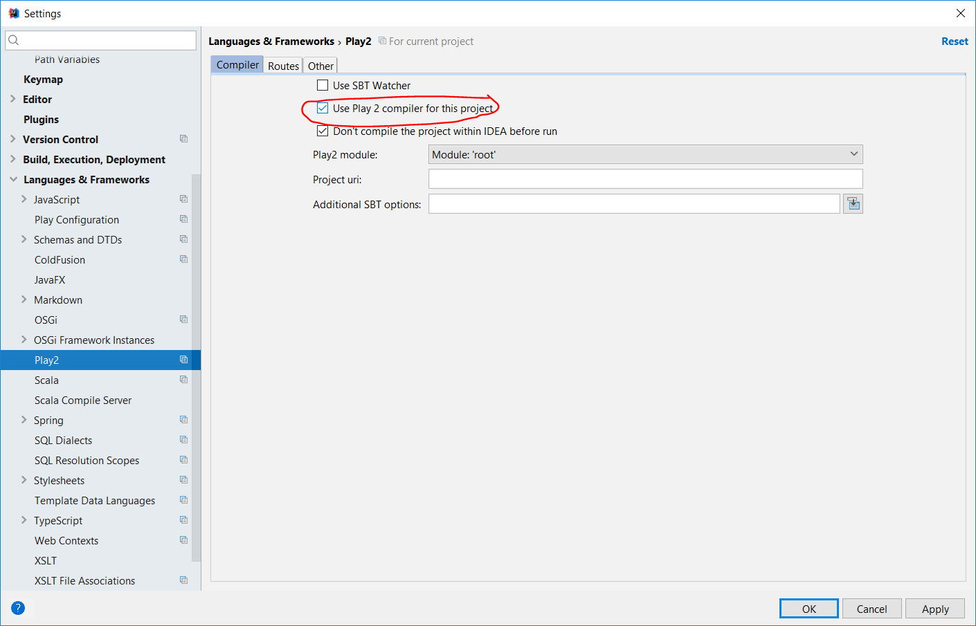

1. Go to Run -> Edit Configurations -> Select “+” and select “Play 2 App”, name it as you want and click OK.

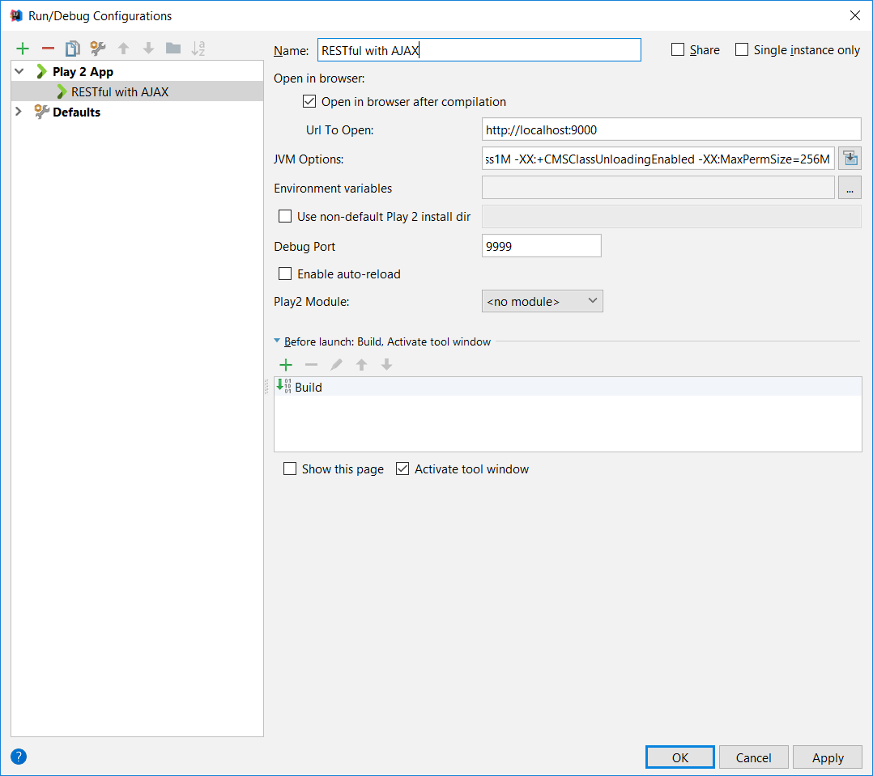

1. Then try running the project for the first time. It takes about 1 minute.

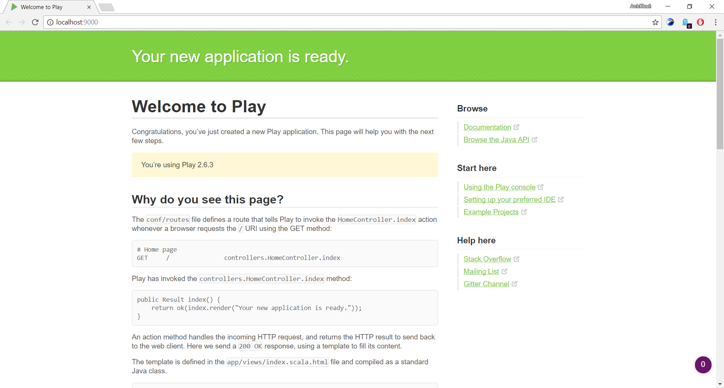

# **Integrate with JPA and Hibernate**

1. Right click on the project’s root and choose “Add Framework Support…”

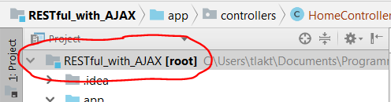

1. Find and choose “Java EE Persistence”, I strongly recommend you to choose persistence.xml with newest version (at the time being, is 2.1) and **DO NOT FORGET** to choose Hibernate as the provider as well as select the “Import database schema”.

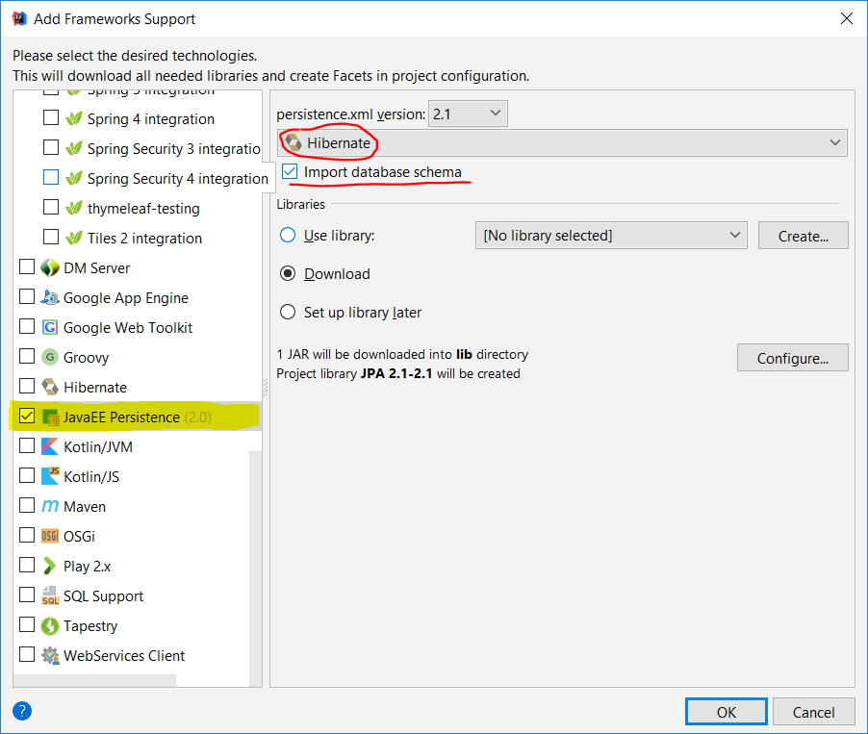

1. Configure and choose your Data Source.

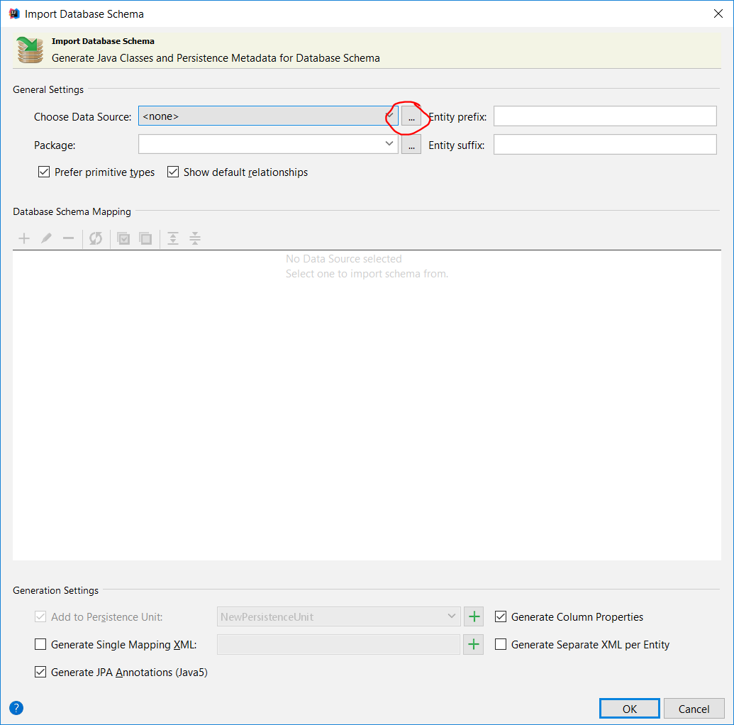

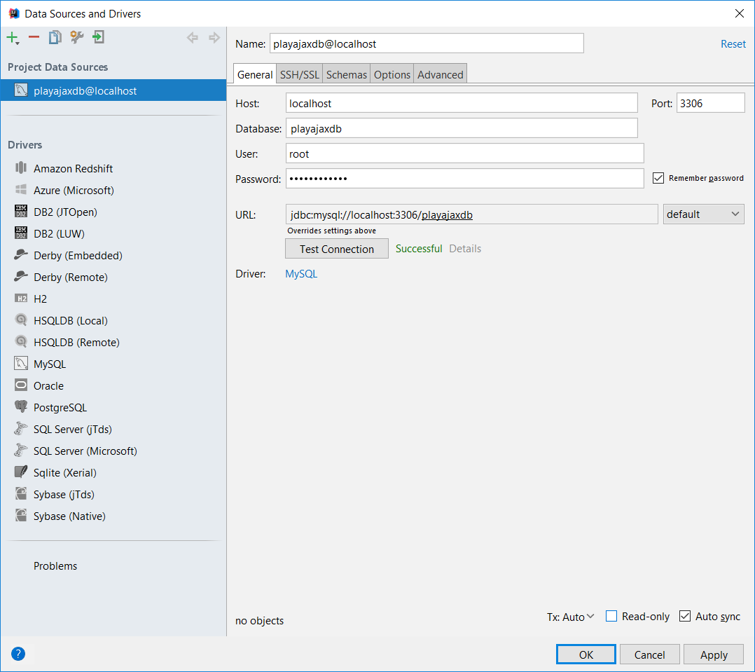

1. Choose your Data Source, remember to name the package for the generated Entities and select the tables which you want to generate. Select “Prefer primitive types” and “Show default relationships” as your own demands. But **REMEMBER** to select “Generate Column Properties”

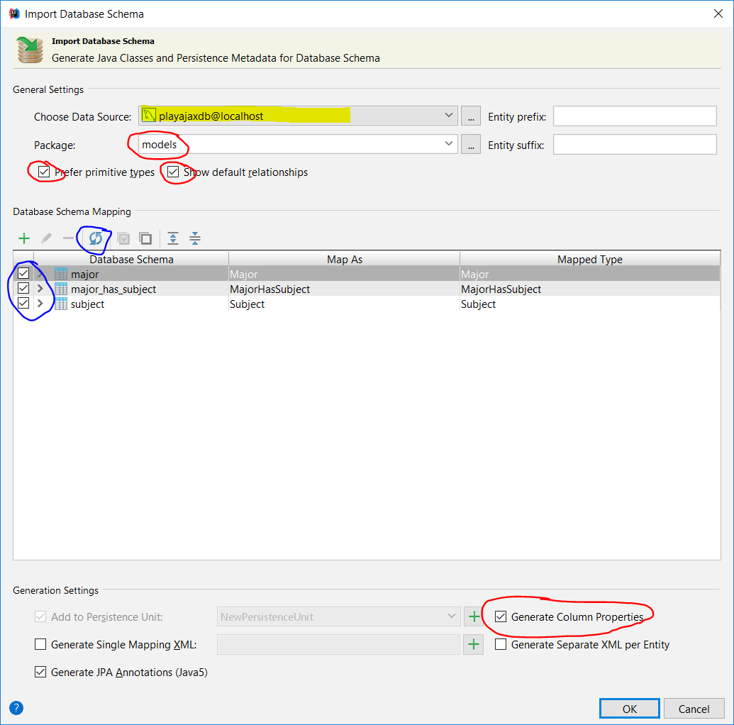

1. Choose **app\[your_package_name]**

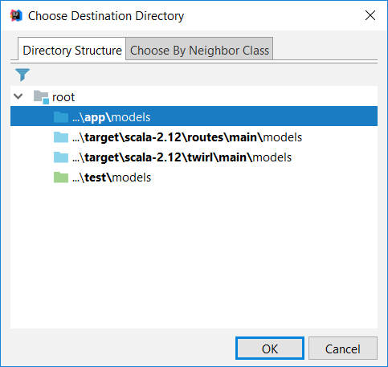

1. Move META-INF from **app\[your_package_name]** to **conf**. Then open **build.sbt** and add the following code:

libraryDependencies ++= Seq(

javaJdbc, **// not sure if this is necessary anyway =)))))**

javaJpa,

"org.hibernate" % "hibernate-entitymanager" % "5.1.0.Final",

"mysql" % "mysql-connector-java" % "5.1.41"

)

Save and select “Enable auto-import”. Wait about 30 seconds.



1. Open **application.conf** and **persistence.xml**. Then configure like below.

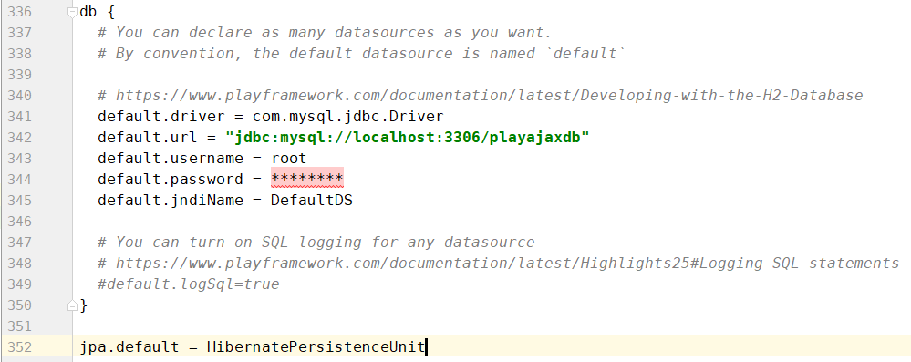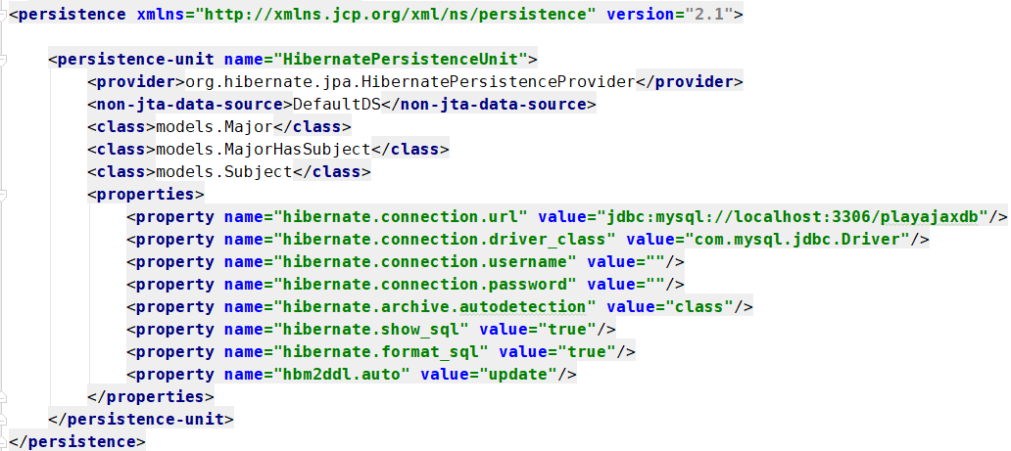

1. Then clear all of the <property> tags inside <properties> and add

**transaction-type="RESOURCE_LOCAL"** to <persistence-unit>. The result should be like below.

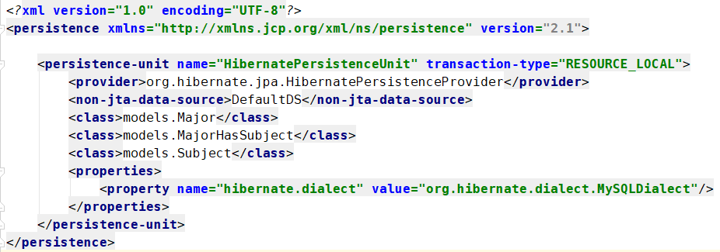

1. Try running the project again, if there is no Compilation error, you should be good to continue developing.